Sonoff is a wifi connected device manufactured by Itead in China. They are intended to be used in a cloud based home automation platform in conjunction with the manufacturers application software. The default configuration necessitates a subscription to their server located off-shore. This isn’t a good idea for security conscious consumers. Tasmota is a firmware package that can be flashed into the ESP8266 chip to enable the unit to be controlled locally using commands directly to its’ IP address, through a built-in web page, or using MQTT. MQTT is the preferred method of access, and with the utilization of the node-red framework and node-red dashboard feature powerful automation scenarios can be devised that can interface with hundreds of similar ESP devices on the market. Tasmota is capable of interfacing to scores of these module, although the simple switches enclosed are only capable of basic On/Off line switching operations.

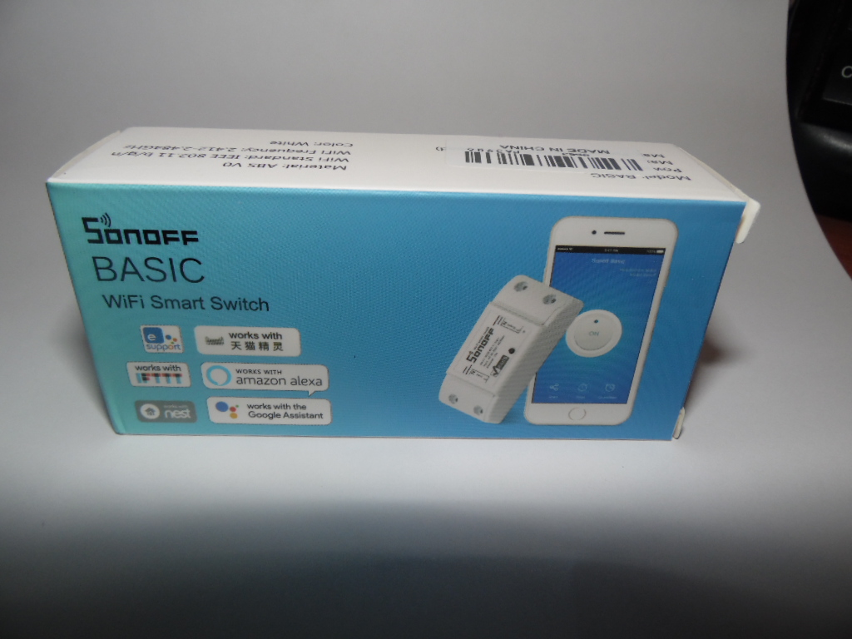
This is the basic Sonoff

The switch contains the PCB, plastic case with cutouts for wiring and strain relief clamps. I soldered a 4-pin header to the board in order to connect to an external programmer.

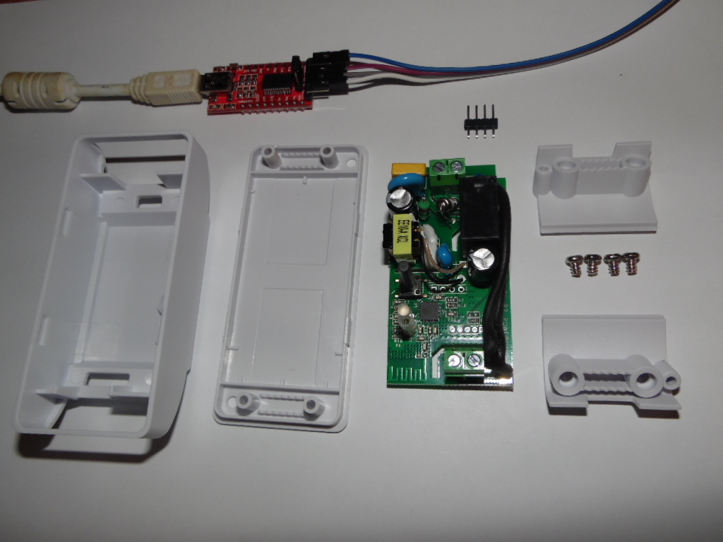

The unit contains an ESP8285 microcontroller, power supply, and a 10 amp line voltage relay. The pcb is not designed for hacking, so a header must be installed to install the firmware.

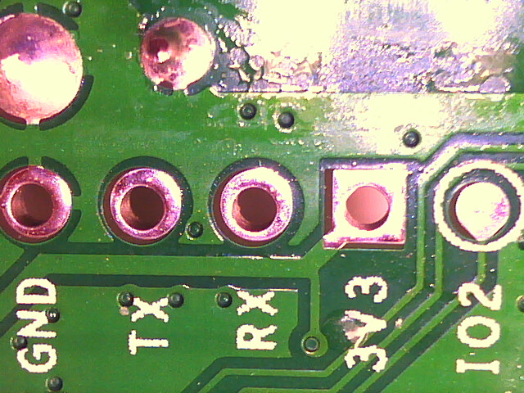

Ground, 3.3v, Tx and Rx are connected to the programmer.

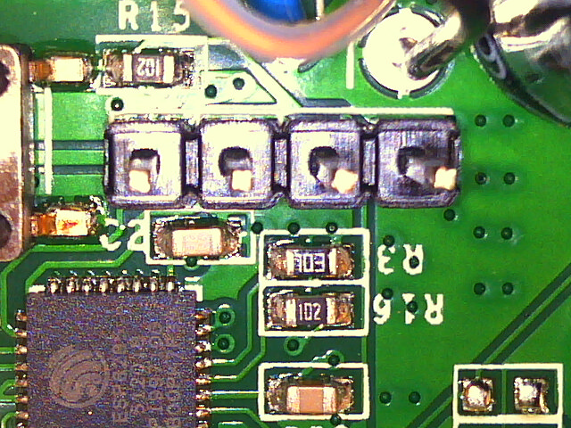
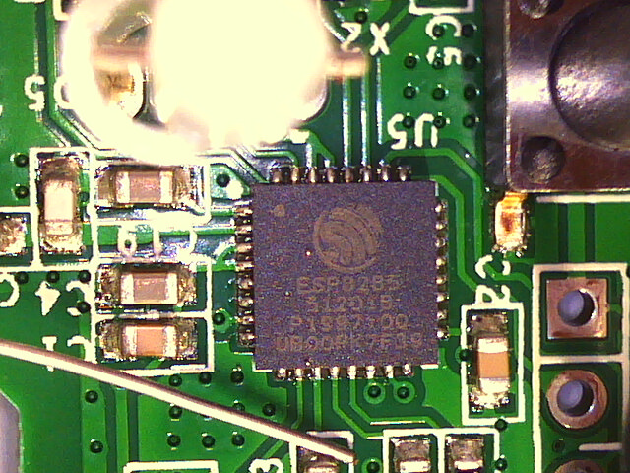

Header pins installed.

ESP8285 processor. The floating wire at bottom left of image is a piece of .038mm solder. That’s about
.015 inches or the thickness of 4 sheets of paper. The leads on the IC are about .010 inch.

The reprogramming is done from a PC utilizing a 3.3v FTDI. There is a python script called esptool that is used to read the MAC address of the board, backup the original configuration, erase the chip and then write the new firmware. After the Sonoff has been reprogrammed and connected to a wall socket, it will appear as an AP on your wireless network. Attach to it and it should present a web page to enable you to configure it to your system. If you don’t see a web page, go to 192.168.4.1 and it should appear.

There are countless YouTube videos and tutorials available on the web for these devices.
Once you have established an IP address and loaded your ssid and password, just point your browser to that address and you should be presented with a web page. From there you can toggle power, give the device MQTT credentials, configure timers and many other parameters.

You will want to make the address of the switches static so that the network doesn’t try to change it on you. I have 4 of them installed with IPs of 10.0.0.10, 10.0.0.20, and so on for the other two.

To turn a device On through the local network I use the following:

sudo curl -o 40log http://10.0.0.40/cm?cmnd=Power%20On

Off:

sudo curl -o 40log http://10.0.0.40/cm?cmnd=Power%20Off

curl -o 40log updates a logfile on disk (called, not surprisingly, 40log) that shows the response state of the last command. On my machine: {“POWER”: ”ON”}. Or off as the case may be.

My cron file is just sudo ./fishon.sh and sudo ./fishoff.sh that calls the curl commands as shown above with the appropriate web address.

I had to use curl to get this to work because I couldn’t figure out how to embed a space character in an http request. That’s what the %20 is between Power and On (or Off).

MQTT:

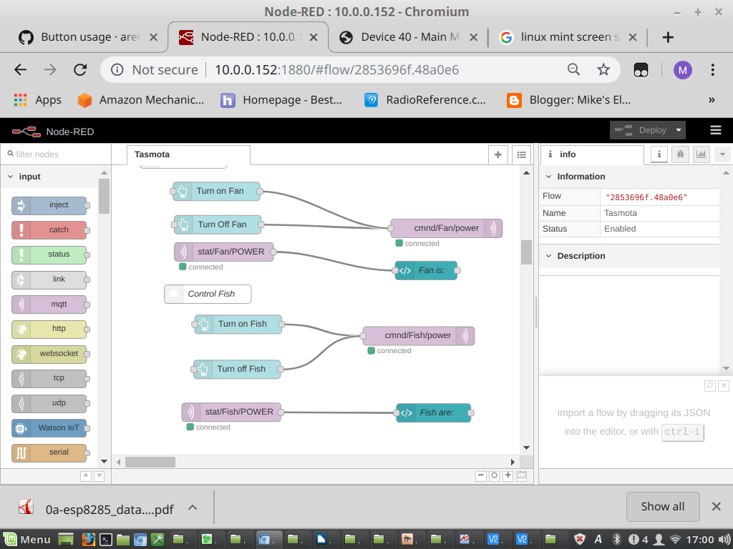
The best way to use these devices is by using node-red and its associated dashboard feature. You configure your mqtt credentials on Tasmota and make a flow with node-red to perform whatever actions you want to perform. Look at the Control Fish section in the middle of the screen. There is an inject node labeled Turn on Fish going to an output node called cmnd/Fish/power. That link sends a message to tell the fish light relay to turn on. Similarly, a Turn off Fish button goes to the same place to turn the light off. Just below that there is a stat/Fish/POWER node connected to the Fish are node that displays the status of the light, on or off. The status is read from the Sonoff over wifi, so it really tells you if it is on or off, not what it was commanded to do.
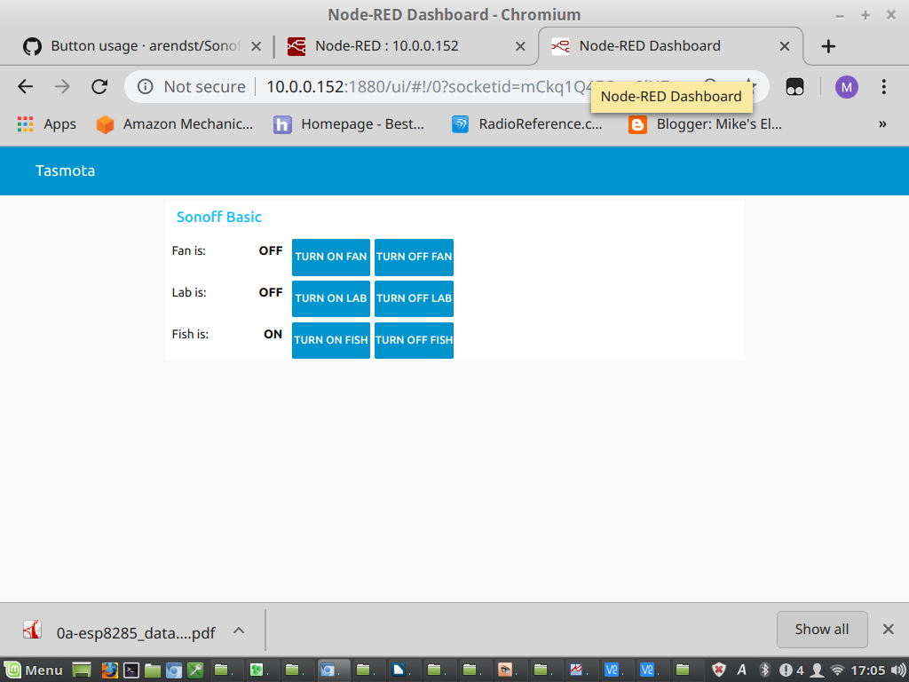

This is the node-red dashboard showing the 3 devices I have configured – Fan, Lab Light, and Fish Light and the status of each. There are buttons to control each entity and the status is updated from the device as mentioned earlier.

In my setup, node-red is running on my Backup Raspberry Pi, mainly because I never turn it off. It runs unattended backups and has the cron file to control power to the fish light. The node-red is started and then you VNC to <Node-red IP Address>:1880. In my case 10.0.0.152:1880. It displays the node-red console as shown above. The dashboard is the same address with /ui appended ie 10.0.0.152:1880/ui. The console and dashboard, being web pages, can be displayed on any PC, android, phone or what have you.

